1, Write a JavaScript program to find the largest of three numbers and display the result in the

screen.

Largest.html

<!DOCTYPE html>

<html lang="en">

  <head>

    <meta charset="UTF-8" />

    <meta http-equiv="X-UA-Compatible" content="IE=edge" />

    <meta name="viewport" content="width=device-width, initial-scale=1.0" />

    <title>Largest amoung three numbers</title>

    <script src="largestnum.js"></script>

    <style>

      input {

        padding-bottom: 5px;

        margin-bottom: 10px;

        border: 1px rgba(255, 250, 240, 0.212) rgba(0, 0, 0, 0.26);

        border-radius: 5px;

        width: 220px;

        height: 20px;

        background: transparent;

      }

    </style>

  </head>

  <body>

    <div

      style="

        display: flex;

        justify-content: center;

        text-align: center;

        align-items: center;

        flex-direction: column;

      "

    >

      <h1 style="text-align: center; padding-bottom: 10px; margin-bottom: 10px">

        Find Largest amoung three numbers

      </h1>

      <input type="text" placeholder="Enter First number" id="num1" />

      <input type="text" placeholder="Enter Second number" id="num2" />

      <input type="text" placeholder="Enter Third number" id="num3" />

      <input

        style="cursor: pointer; width: 150px; height: 20px"

        type="button"

        value="Find Largest"

        onclick="findlargest()"

      />

    </div>

    <br />

    <div>

      <p id="display" style="height: 100px; text-align: center"></p>

    </div>

  </body>

</html>

Largest num.js

function findlargest() {

    let num1 = document.querySelector("#num1").value;

    let num2 = document.querySelector("#num2").value;

    let num3 = document.querySelector("#num3").value;

    if (parseInt(num1) > parseInt(num2) && parseInt(num1) > parseInt(num3))

    {

        document.querySelector("#display").innerHTML="Largest amoung three numbers is : "+parseInt(num1)

        console.log("Largest element is " + parseInt(num1));

    }

     else if (parseInt(num2) > parseInt(num1) && parseInt(num2) > parseInt(num3))

    {

        document.querySelector("#display").innerHTML="Largest amoung three numbers is : "+parseInt(num2)

        console.log("Largest element is " + parseInt(num2));

    }

    else {

        document.querySelector("#display").innerHTML="Largest amoung three numbers is : "+parseInt(num3)

        console.log("Largest element is " + parseInt(num3));

    }

}

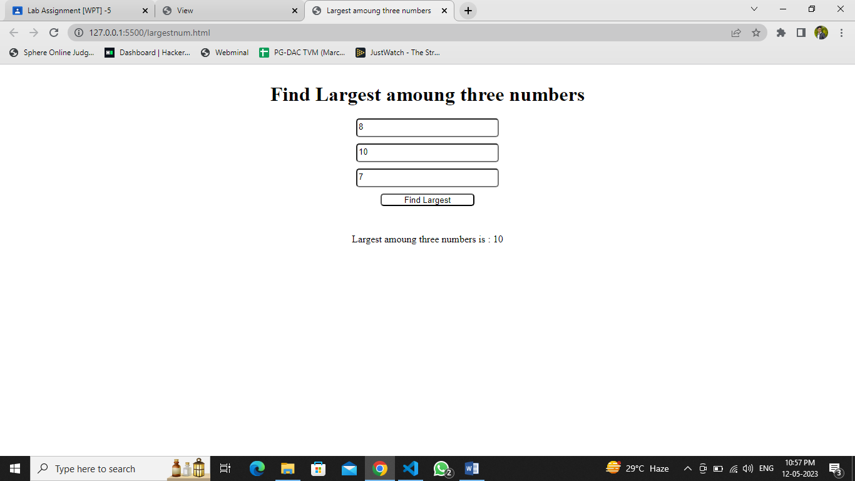

2, Write a JavaScript program to find the square a number and display the result in the

console.

Square.html

<!DOCTYPE html>

<html lang="en">

  <head>

    <meta charset="UTF-8" />

    <meta http-equiv="X-UA-Compatible" content="IE=edge" />

    <meta name="viewport" content="width=device-width, initial-scale=1.0" />

    <title>Find Square</title>

    <script src="square.js"></script>

    <style>

      input {

        padding-bottom: 5px;

        margin-bottom: 10px;

        border: 1px rgba(255, 250, 240, 0.212) rgba(0, 0, 0, 0.192);

        border-radius: 5px;

        width: 220px;

        height: 20px;

        background: transparent;

      }

    </style>

  </head>

  <body>

    <div

      style="

        display: flex;

        justify-content: center;

        text-align: center;

        align-items: center;

        flex-direction: column;

        height: 300px;

      "

    >

      <h1 style="text-align: center; padding-bottom: 10px; margin-bottom: 10px">

        Find Square of number

      </h1>

      <input type="text" placeholder="Enter First number" id="num1" />

      <input

        style="cursor: pointer; width: 150px; height: 20px"

        type="button"

        value="Find Square"

        onclick="findSquare()"

      />

      <p id="display" style="height: 100px; text-align: center"></p>

    </div>

  </body>

</html>

function findSquare() {

    let num1 = document.querySelector("#num1").value;

    let sqr = parseInt(num1) \* parseInt(num1)

    document.querySelector("#display").innerHTML = "Square is : " + parseInt(sqr)

    console.log("Square is : " +parseInt(sqr))

}

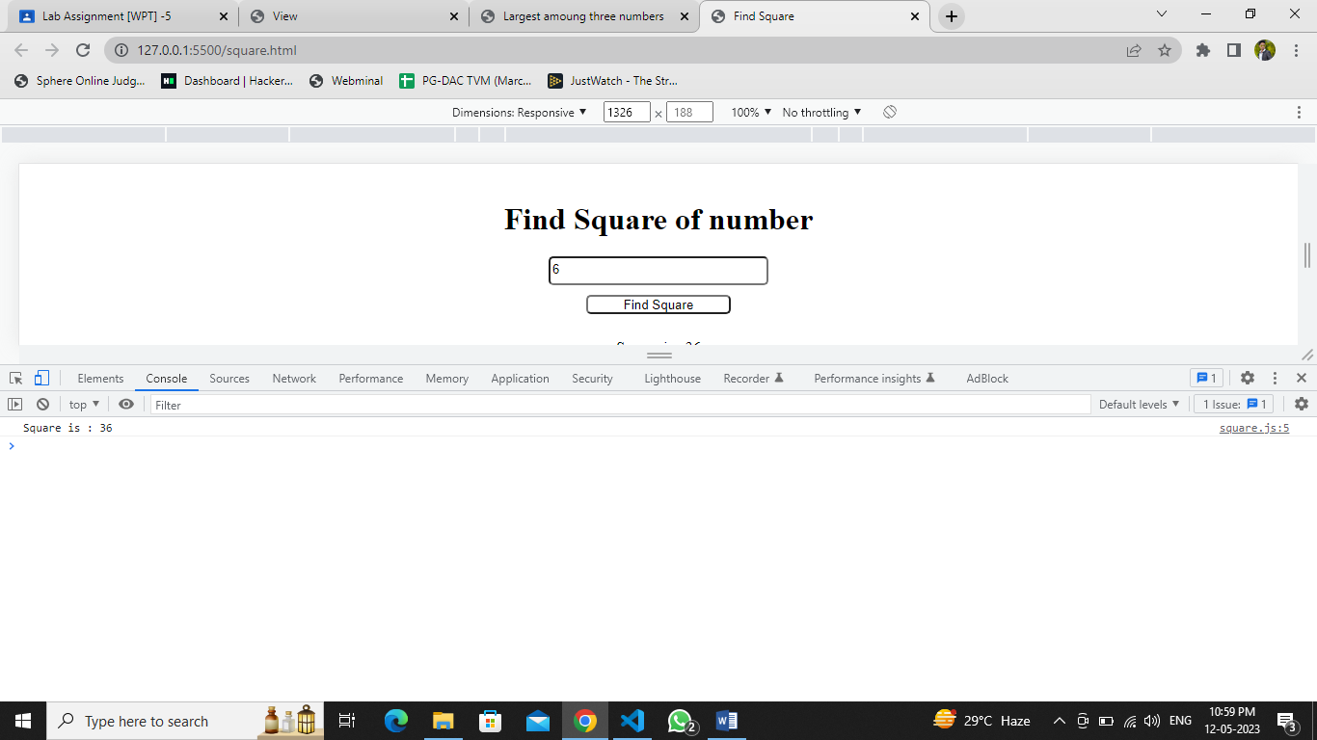

3 (i) write a JS program to create a paragraph and create seven button [VIBGYOR] click on

the first button violet above paragraph will show on violet colour. Do the same process on all

buttons, and also set a reset button it reset to default colour

(ii) Add two buttons on the above paragraph it will increase and decrease the size of content.

Change color.html

<!DOCTYPE html>

<html lang="en">

  <head>

    <meta charset="UTF-8" />

    <meta http-equiv="X-UA-Compatible" content="IE=edge" />

    <meta name="viewport" content="width=device-width, initial-scale=1.0" />

    <title>Chnage color</title>

    <script src="changecolor.js"></script>

    <style>

      input {

        margin-right: 10px;

        padding: 5px;

        cursor: pointer;

        width: 150px;

        height: 40px;

        border: 1px rgba(255, 250, 240, 0.212) rgba(0, 0, 0, 0.26);

        border-radius: 5px;

      }

    </style>

  </head>

  <body>

    <div

      style="

        display: flex;

        justify-content: center;

        flex-direction: column;

        height: 60vh;

      "

    >

      <p style="text-align: center">

        The history of Java is very interesting. Java was originally designed

        for interactive television, but it was too advanced technology for the

        digital cable television industry at the time. The history of Java

        starts with the Green Team. Java team members (also known as Green

        Team), initiated this project to develop a language for digital devices

        such as set-top boxes, televisions, etc. However, it was best suited for

        internet programming. Later, Java technology was incorporated by

        Netscape. The principles for creating Java programming were "Simple,

        Robust, Portable, Platform-independent, Secured, High Performance,

        Multithreaded, Architecture Neutral, Object-Oriented, Interpreted, and

        Dynamic". Java was developed by James Gosling, who is known as the

        father of Java, in 1995. James Gosling and his team members started the

        project in the early '90s.

      </p>

      <br /><br />

      <div style="display: flex; justify-content: center">

        <input

          style="background-color: Violet"

          type="button"

          value="Violet"

          onclick="changecolor('Violet')"

        />

        <input

          style="background-color: Indigo"

          type="button"

          value="Indigo"

          onclick="changecolor('Indigo')"

        />

        <input

          style="background-color: Blue"

          type="button"

          value="Blue"

          onclick="changecolor('Blue')"

        />

        <input

          style="background-color: green"

          type="button"

          value="Green"

          onclick="changecolor('Green')"

        />

        <input

          style="background-color: Yellow"

          type="button"

          value="Yellow"

          onclick="changecolor('Yellow')"

        />

        <input

          style="background-color: Orange"

          type="button"

          value="Orange"

          onclick="changecolor('Orange')"

        />

        <input

          style="background-color: Red"

          type="button"

          value="Red"

          onclick="changecolor('Red')"

        />

        <input type="button" value="Reset" onclick="changecolor('Black')" />

      </div>

      <br />

      <div style="display: flex; justify-content: center">

        <input

          type="button"

          value="Increase Font"

          onclick="applyFont('21px')"

        />

        <input

          type="button"

          value="Decrease Font"

          onclick="applyFont('10px')"

        />

        <input type="button" value="Reset Font" onclick="applyFont('')" />

      </div>

    </div>

  </body>

</html>

Change color.js

function changecolor(color) {

    let co = document.querySelector("p");

    co.style.color=color;

}

function applyFont(p1) {

    let p = document.querySelector("p");

    p.style.fontSize=p1;

}

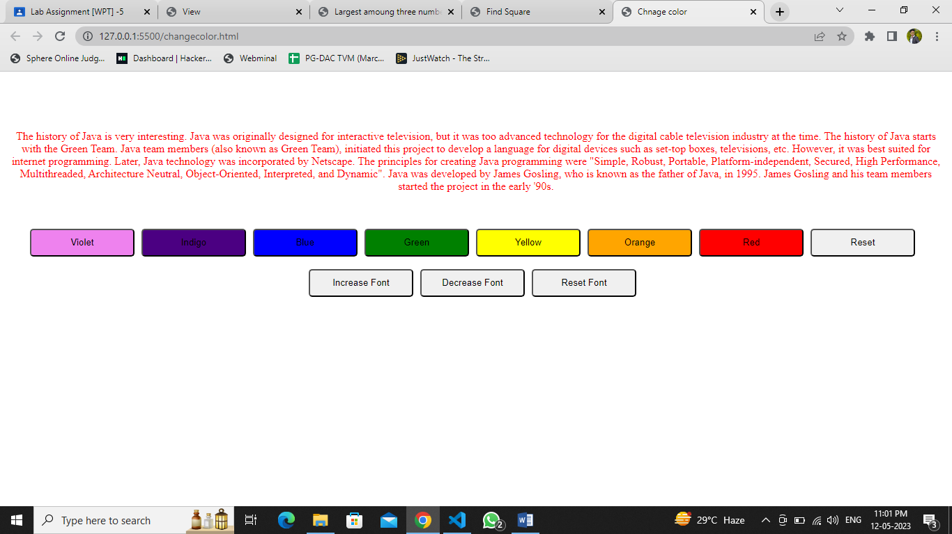

4 (i) write a JS Program to select an image – and also create different buttons like Front View

back View, Side view ,top view etc.... Click on that button it will show the corresponding

views

(ii) Add a like or Dislike Button on the above Program, click on that button it will increase

the count.

View.html

<!DOCTYPE html>

<html lang="en">

  <head>

    <meta charset="UTF-8" />

    <meta http-equiv="X-UA-Compatible" content="IE=edge" />

    <meta name="viewport" content="width=device-width, initial-scale=1.0" />

    <title>View</title>

    <script src="viewside.js"></script>

    <link

      rel="stylesheet"

      href="https://cdnjs.cloudflare.com/ajax/libs/font-awesome/4.7.0/css/font-awesome.min.css"

    />

    <style>

      input {

        margin-right: 10px;

        padding: 5px;

        cursor: pointer;

        width: 150px;

        height: 40px;

        border: 1px rgba(255, 250, 240, 0.212) rgba(0, 0, 0, 0.26);

        border-radius: 5px;

      }

    </style>

  </head>

  <body>

    <div

      style="

        height: 300px;

        display: flex;

        justify-content: center;

        align-items: center;

      "

    >

      <img

        style="object-fit: cover; height: 300px"

        id="imgid"

        src="frontview1.jpg"

      />

    </div>

    <br />

    <div

      style="

        height: 300px;

        display: flex;

        justify-content: center;

        align-items: center;

        flex-direction: column;

      "

    >

      <input type="button" value="Front View" onclick="changeView(1)" />

      <input type="button" value="Top View" onclick="changeView(2)" />

      <input type="button" value="Side View" onclick="changeView(3)" />

      <input type="button" value="Back View" onclick="changeView(4)" />

      <br />

      <br />

      <div style="display: flex; justify-content: flex-start">

        <span onclick="thumbsup()" style="margin-right: 5px"

          ><i class="fa fa-thumbs-up" style="font-size: 30px"></i

        ></span>

        <p style="margin-right: 100px" id="thumbup">0</p>

        <span onclick="thumbsdown()" style="margin-right: 5px"

          ><i class="fa fa-thumbs-down" style="font-size: 30px"></i

        ></span>

        <p id="thumbown">0</p>

      </div>

    </div>

  </body>

</html>

View.js

function changeView(p) {

    let v = document.querySelector("#imgid");

    if (p == 1)

    {

        v.setAttribute("src", "frontview.jpg");

    }

    else if (p == 2)

    {

        v.setAttribute("src", "topview.jpg");

    }

    else if (p == 3)

    {

        v.setAttribute("src", "Sideview.jpg");

    }

    else {

        v.setAttribute("src", "backview.jpg");

    }

}

    function thumbsup() {

  let Counterinc = document.querySelector("#thumbup");

  let existingValue = Counterinc.innerHTML;

  let newValue = parseInt(existingValue) + 1;

  Counterinc.innerHTML = newValue;

}

function thumbsdown() {

    let Counterinc= document.querySelector("#thumbown");

    let existingValue = Counterinc.innerHTML;

    let newValue = parseInt(existingValue) + 1;

    Counterinc.innerHTML = newValue;

}

